**Environmental Science**

**Section B**

**1. Concept of an Ecosystem:**

An Ecosystem is defined as discrete structural, functional and life sustaining environmental system. It includes region with specific landscape such as forest, grassland, desert, wetland etc. It is composed of biotic an abiotic components. Abiotic components of ecosystem provide suitable life sustaining conditions for biotic components. Ecosystems are divided in to terrestrial and aquatic ecosystem which forms the major ***habitats*** on the earth for living organisms. The non living components and the living components interacts each other at different point of time for different reasons such as energy transfer, nutrient transport, nutrient recycling etc.

***Habitat:*** it is the place where an living organism is provided with suitable life sustaining conditions and complete its whole life cycle.

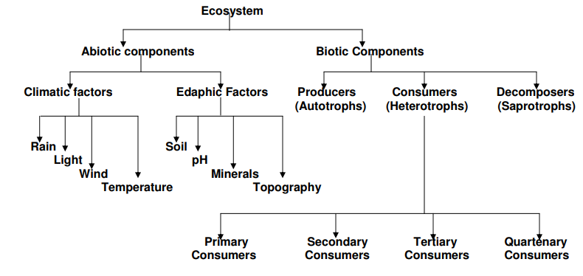

Living components are found in a thin segment of earth’s lithosphere, hydrosphere and atmosphere which is termed as biosphere. Biosphere can be classified on the basis of sub-global and national/ state level.

1. At sub global level it is called as bio-geographical realms, there are 6 bio-geographical realms:

1. Eurasia (palaeartic realm)
2. South and South East Asia (Oriental realm)
3. North America (Nearctic realm)
4. South America (Neotropical realm)
5. Africa (Ethopian realm)
6. Australia (Australia realm)

2. National level biogeographical regions: includes the following:

1. Himalayas
2. Gangetic plains
3. The highlands of central Asia
4. Western and eastern ghats
5. Semi- arid desert in the west
6. Deccan plateau
7. Coastal belts
8. Andaman and Nicobar

***Lithosphere****:* It is the upper earth crust which consist the soil and essential elements.

***Hydrosphere****:* The combined amount of aquatic system found above or below the earth*.*

***Atmosphere****:* The gaseous surrounding of earth which consist of gases, water vapour, dust and particulate matters.

***Ecotope:*** It is defined as smallest ecological distinct features which represents relatively homogenous, spatially explicit landscape functional units.

*Landscape:* The land form feature found on earth surface such as vegetation, hills, mountains etc.

**Structure of ecosystem:**

Structure of ecosystem involves biotic and abiotic components, which differs in different ecosystem. It needs matter (water, oxygen, mineral, carbon dioxide), different types of organisms and continuous recycling of energy. These requirements are met by two imporattn components present in ecosystem; biotic components and abiotic components.

1. **Forest Ecosystem:** Forst ecosystem is dominated by plant community (trees, shurubs, climbers and ground cover). Natural forest ecosystem involves National parks, wild life sancturies, biosphere reserves etc.
2. **Abiotic component**: Temperartue, rainfall and elevation (altitude) predominantly affect the type of forest. Soil composition also affect the type of vegetation in forest.

Biotic component:

1. **Biotic component**: Community formed by plant and animal is considered as biotic component. Composition of plant and animal community varies with forest type.

**Plants**: Trees, shrubs, climbers, grasses, and herbs in the forest. These include species that flower (angiosperms), and non-flowering species (gymnosperms) such as ferns, bryophytes, fungi and algae.

**Animals:** species of mammals, birds, reptiles, amphibians, fish, insects and other invertebrates and a variety of microscopic animals.

|  |  |  |
| --- | --- | --- |
| **Forest Type** | **Plants** | **Common Animals** |
| Himalayan Coniferous | Pine, deodar | Wild goats and sheep |
| Himalayan Broadleaved | Maple, oak |  |
| Evergreen North-east | Jamun, Ficus | Tiger, Leopard, Sambar |
| Western Ghats | Dipterocarpus | whistling thrush, Malabar Pied |
| Deciduous – Dry | Teak, Ain, Terminalia | Tiger, Chital, Barking deer |
| Moist | Sal |  |
| Thorn and scrub | Babul, Ber, Neem | Blackbuck, Chinkara, Fourhorned |
| Mangrove Delta | Avicenia | Crocodile, shorebirds – sandpipers |

**2) Grassland Ecosystem:**

It refers to vegetation formed by grasses and small annual plants which are adopted to India’s various climatic conditions**.** These form a variety of grassland ecosystems with their specific plants and animals.

Abiotic **components**:

* Grassland region receives very low rainfall.
* Soil depth and quality is poor.
* Low rainfall prevents the growth of a large number of trees and shrubs, but is sufficient to support the growth of grass cover during the monsoon.

`Biotic components:

* A variety of grasses, herbs, and several species of insects, birds and mammals have evolved so that they are adapted to these wide-open grass covered areas.
* Himalayan pasture belt, Terai, Semi-arid plains of Western India, Cen- Semi-arid plains of Western India, Central India and the Deccan, Shola grasslands are the major grasslands found in India.

**Desert Ecosystem:**

Deserts ecosystems located in tropical regions are environment of extremes, with lack of moisture and generally synonymous with arid regions. They are some of the hottest and driest areas of the planet, with no or sporadic rainfall. These conditions are due to some different conditions as continentality, topography and subtropical high pressure cells’ influence. These kinds of deserts are located in the southern and northern hemispheres, especially between 5 and 30 degrees of latitude.

**Abiotic components:**

* It is the driest and hottest place on earth. Rainfall is sporadic and in some years no measurable precipitation falls at all.
* The terribly dry conditions of the deserts are due to the year-round influence of subtropical high pressure.
* Desert soil types vary greatly, influencing a given location’s drainage as well as evaporation.
* Desert sunlight can be intense courtesy of prevailing cloud-free conditions and, in the subtropics, the position of the sun.

Biotic components:

* Producers involve shrubs, especially some grasses, bushes and few trees. Son lower plants like xerophytic mosses and lichens may also be present.
* Reptiles, insects, nocturnal rodents, birds, and camels are the main consume! They are able to live under xeric conditions.
* Deserts have poor vegetation with a very low amount of dead organism matter. The decomposers are fungi and bacteria, most of which are thermophilic.

**Aquatic Ecosystem :**

Aquatic ecosystem is the most diverse ecosystem in the world. The first life originated in the water and first organisms were also aquatic where water was the principal external as well as internal medium for organisms. Thus water is the most vital factor for the existence of all living organisms. Water covers about 71% of the earth of which more than 95% exists in gigantic oceans. A very less amount of water is contained in the rivers (0.00015%) and lakes (0.01%), which comprise the most valuable fresh water resources. Global aquatic ecosystems fall under two broad classes defined by salinity – freshwater ecosystem and the saltwater ecosystem. Freshwater ecosystems are inland waters that have low concentrations of salts (< 500 mg/L). The salt-water ecosystem has high concentration of salt content (averaging about 3.5%).

An aquatic ecosystem (habitats and organisms) includes rivers and streams, ponds and lakes, oceans and bays, and swamps and marshes, and their associated animals. These species have evolved and adapted to watery habitats over millions of years. Aquatic habitats provide the food, water, shelter, and space essential for the survival of aquatic animals and plants. Aquatic biodiversity is the rich and harbors variety of plants and animals-from primary producers algae to tertiary consumers large fishes, intermittently occupied by zooplankton, small fishes, aquatic insects and amphibians. Many of these animals and plants species live in water; some like fish spend all their lives underwater, whereas others, like toads and frogs, may use surface waters only during the breeding season or as juveniles.

**Lotic Ecosysetm:** The term lotic (from lavo, meaning „to wash') represents running water, where the entire body of water moves in a definite direction. It includes spring, stream, or river viewed as an ecological unit of the biotic community and the physiochemical environment. Lotic ecosystems are characterized by the interaction between flowing water with a longitudinal gradation in temperature, organic and inorganic materials, energy, and the organisms within a stream corridor. These interactions occur over space and time.

**Lentic Ecosystem:** Lentic ecosystem refers to the still water bodies. It includes ponds, lakes etc. These lentic ecosystem is further divided in to – pelagic and benthic systems. Benthic system is subdivided into littoral and profundal types. The species composition of communities of all those types is greatly influenced by the nutrient status of the water concerned. The pelagic habitat is that of the open water away from the influence of shore or bottom substrate, while benthic habitat is associated with the substrate of the lake. The littoral habitat is extending from the shoreline out to the deeper water. The plankton community, phytoplankton and zooplankton, occupy the regions of high light intensities namely on the surface layer of pelagic zone and the littoral zone. Some of the zooplankton members also inhabit the benthic zone feeding on detritus and sinking phytoplankton. Fishes occupy the littoral, pelagic and occasionally profundal zones, when the dissolved oxygen content in the lake is high. Macro invertebrates are confined to the benthic zone.

**Pond:** A pond is an aquatic body belongs to the Lentic ecosystem**.** Usually they contain shallow water with marsh and aquatic plants and animals.[[2]](https://en.wikipedia.org/wiki/Pond#cite_note-2)The type of life in a pond is generally determined by a combination of factors including water level regime (particularly depth and duration of flooding) and nutrient levels, but other factors may also be important, including presence or absence of shading by trees, presence or absence of streams, effects of grazing animals, and salinity.

**Lake:** Lakes are inland bodies of water that lack any direct exchange with an ocean. Lake ecosystems are made up of the physical, chemical and biological properties contained within these water bodies. Lakes may contain fresh or salt water (in arid regions). They may be shallow or deep, permanent or temporary. Lakes of all types share many ecological and biogeochemical processes and their study falls within the discipline of ‘limnology’. Lakes are superb habitats for the study of ecosystem dynamics: interactions among biological, chemical and physical processes are frequently either quantitatively or qualitatively distinct from those on land or in air. Because the boundaries between water and land, and water and air are distinct, there is tight coupling among many ecosystem components. Although lakes contain 5 0.01% of all the water on the Earth’s surface, they hold 498% of the liquid surface freshwater. Many organisms depend on freshwater for survival, and humans frequently depend on lakes for a great many ‘goods and services’ such as drinking water, waste removal, fisheries, agricultural irrigation, industrial activity, and recreation. For these reasons lakes are important ecosystems. Lake ecosystems are influenced by their watersheds, the geological, chemical and biological processes that occur on the land and streams that lie uphill. The movement of chemicals, sediments, detritus, and of many organisms, is typically unidirectional from the watershed to the lake, but fish may migrate upstream, and aquatic insects may emerge and disperse on to land. A lake and its watershed are often considered to be a single ecosystem.

**Estuaries:** Estuaries are places where fresh and salt water mix. Typically they occur where rivers enter the sea. Estuary circulation is governed by density stratification mainly driven by salt concentration not temperature. The specific gravity of seawater is about 1.025. In other words seawater weighs about 2.5% more than an equivalent volume of fresh water. On the other hand estuaries are often tidal and shallow, and river currents are often strong. Hence salt and fresh water are often mixed in estuaries despite strong density stratification. Left, salt wedge estuaries often occur at the mouths of very strongly flowing rivers like the Mississippi and the Amazon.

**Concept of producers/ consumers and decomposers**

**Producers**: These are green photosynthetic plants which perform photosynthesis process for synthesis of carbohydrate / starch in presence of CO2 , sunlight and water. Therefore, producers are also termed as autotrophs. The type of plant species varies with ecosystems. Producers determine the productivity of ecosystem and transfer the energy to consumers.

**Consumers:** Consumers are the heterotrophs which depend on producer to meet their energy/ nutritional requirements. Consumers don’t possess the potential for photosynthesis process. **Consumers are further classified in to (1) Herbivorous (2) carnivorous (3) Omnivores.**

1. **Herbivore:** Consumer which directly depends on the producer to meet the energy requirement. Example: Cattles, Grasshopper etc. Herbivores are also termed as primary consumer.
2. **Carnivore:** Consumer which directly depends on primary consumer/ herbivores to meet their energy requirement. Example: Snake, Eagles, Venus Fly Trap. Some plants are also carnivores as they full fill their essential nutrients requirements by preying insects such as Pitcher plant. Carnivores are also termed as secondary consumer.
3. **Tertiary Consumer:** Some animal feed on secondary consumer and thus they are termed as top predators in a food chain. This means there is no natural predator of top consumers. Example: Lion, Tiger, Shark etc.

**Decomposers**: These are mainly bacteria and fungi. Their primary purpose in the ecosystem is to decompose the complex organic material into the simple inorganic material so that it can be use for producers to prepare food.

**Food Chain**:

The sequential inter-linking of organisms involving transfer of food energy from the producers, through a series of organisms with repeated eating and being eaten is referred as **“food chain”**. The biotic components of the ecosystem are linked to each other through food chain. In a typical food chain, producers are at the bottom and their role is to provide food for rest of the community utilizying solar energy. Other organisms belong to the consumers and finally decomposers are present at the bottom to recycle the organic content. In this manner, a nutritive interaction relationship exists between the living organisms of an ecosystem. It is always straight and always follow progressive straight line. The flow of energy is also unidirectional, from sun to producer and then different series of consumers. In a typical food chain, there are always 4 or 5 trophic level in the food chain. The distinct sequential steps in the straight food chains are referred as different trophic levels. For ex. Green plants stand at the first trophic level; the herbivorous are the second trophic level; and flesh eaters represent the third trophic levels. The position of plant is at the bottom but the position of other organism varies to different trophic level in different food chains.

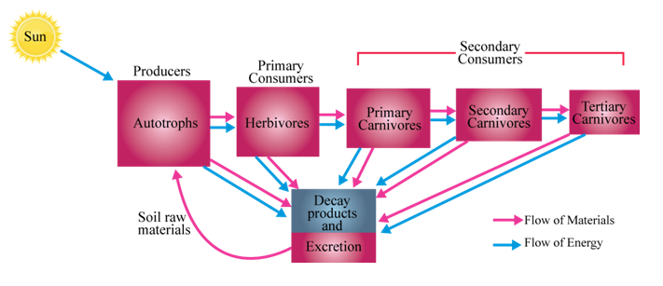

Figure: interaction between different organism in ecosystem.

**Types of Food Chain**: There are two different types of food chains; grazing food chain and detritus food chain.

1. **Grazing food chain:** In the grazing food chain, solar energy is entrapped by the plants and then biomass, in tuen eaten by the herbivorous, and these are subsequently been consumed by a variety of carnivorous. These are longer food and these food chains end at the decomposer level.  Here are two typical example of this type of food chain to understand this type of food chain.
2. **Detritus food chain:** Unlike grazing food chain, detritus food chain starts with the dead organic matter either from fallen leaves or dead animal bodies. This food chain doen’t depends on solar energy. Common example of detritus food chain is marsh land where mangrove leaves fall into the warm, shallow water (Figure 39.4). The detritus eating animals ex. Bacteria, fungi and protozoan act upon the dead matter of dead leaves to covert them into simple inorganic substances. The detritivorous are subsequently eaten by insect larvae, grass shrimp, copepods, crabs, nematodes, bivalve mollusks, amphipods, mysids etc. In the last step, the detritus consumers are finally eaten by fishes.

**Food Web:** The different food chains are inter connected at various trophic level to develop a food web. For example, in grassland ecosystem, grass is consumed by the rabbit but in their absence, it may be eaten by the grazing cattle. Similarly, rat or mouse is eaten by snake but snake can be eaten by predatory birds. In contrast to food chain, food web has several distinct characteristic. **(1)** Food web are never straight. **(2)** Food web is formed due to interlinking of food chains.

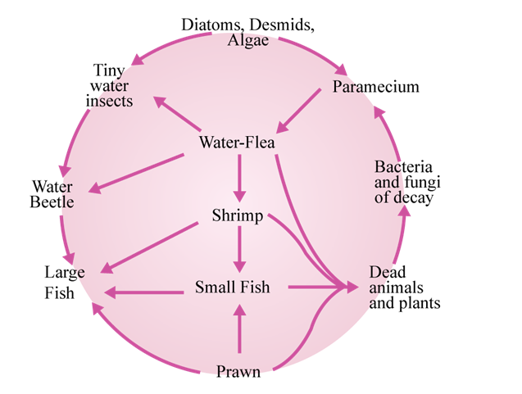

**Figure**: Food Web in a Pond

**Ecological Pyramids:**

In a food chain, producers and consumers at different trophic level are connected in terms of number, biomass and energy. These properties reduces from producers to consumers and representing these parameters for food chain gives a pyramid with a broad base and a tapering apex Ecological pyramids can be of three types:

1. Pyramid of Numbers (b)
2. pyramid of biomass
3. pyramid of energy

A single mango tree supports large number of birds, which in turn supports a large number of parasites like lice and bugs. Hyperparasites, such as bacteria and fungus are the greatest in the number and occupy the top of the invertes pyramids.

**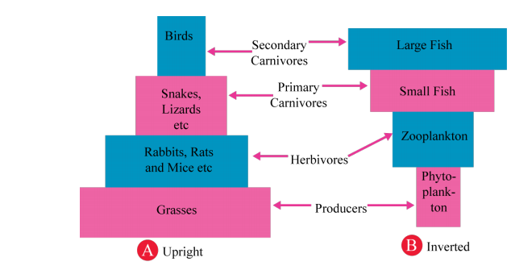  
Energy flow in ecosystem:**

Sun is the ultimate source of energy on earth and plants utilizes it to produce food for rest of the member of the ecosystem. Only the 1% of the total energy fall on green part of leaves is changed into the potential energy of the organic substances, the rest of the energy dissipates as heat. To explain the flow of energy, **lindermann proposed the law of ten per cent law**. This law proposed that during transfer of food energy from one trophic level to the other, only 10% is stored at higher trophic and the rest 90% is lost in respiration, decomposition and waste in the form of heat. For example, 5000 jules fall on leaves, it will convert only 50 jules into the chemical form (food). It will be eaten by rabbit, he will get only 5 jules (10% of 50 jules) on next trophic level. Rabbit will be consumed by carnivorous and they can be able store only 0.5 jules (10% of 5 jules).

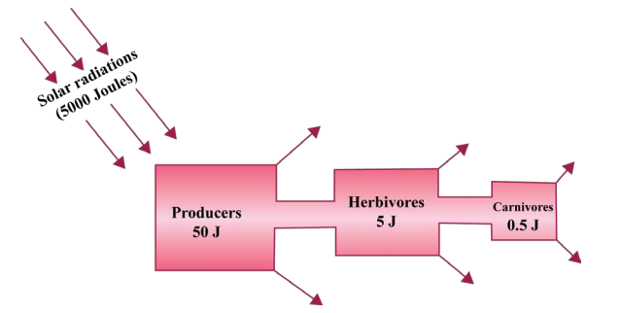 **Figure:** Linear flow of energy in ecosystem

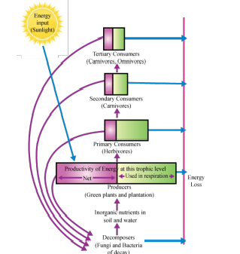

**Figure: 10 percent law in energy transfer in ecosystem**

**Ecological succession:** The series of changes in an ecosystem when on community is replaced by another community as a result of changes in biotic and abiotic factors. Followings are the characteristics of ecological succession:

1. It can regenerate a damaged community
2. It can create a community in an uninhabited area.
3. It occurs in all type of ecosystem.

**Primary Succession**: the process of developing an ecosystem in an area that was previously uninhabited. example: sides of volcanoes

**Secondary succession**: It refers to the process of repairing a damaged ecosystem. It occurs in an area where the soil was left intact. Example: succession after natural disaster.

**Pioneer community**: The first community which appears in the process of ecological succession such as Lichens.

**Climax community**: These are the communities which are most developed in the process of ecological succession. These communities are highly stable and no other community replaced climax community.

**Biodiversity**:

The term biodiversity refers to the variations in life forms. It involves different kind of flora and fauna along with microorganism found in the biosphere.

Biological diversity or biodiversity is generally divided into three fundamental categories: genetic diversity, species diversity, and ecosystem diversity.

1. Genetic diversity:

Genetic diversity refers to the differences in genetic make-up between distinct species and to genetic variations within a single species. Individuals’ belonging to a species share, by definition, certain characteristics, but genetic variation determines the particular characteristics of individuals within the species.

1. **Species diversity:**

Species diversity is measured in relation to a given area - from a small field to the entire planet. It can be assessed in terms of the number of species or the range of different types of species an area contains.

1. **Ecosystem diversity:**

Ecological diversity is a type of [biodiversity](https://en.wikipedia.org/wiki/Biodiversity). It is the variation in the [ecosystems](https://en.wikipedia.org/wiki/Ecosystems) found in a region or the variation in ecosystems over the whole planet. Ecological diversity includes the variation in both [terrestrial](https://en.wikipedia.org/wiki/Terrestrial_ecosystem) and [aquatic ecosystems](https://en.wikipedia.org/wiki/Aquatic_ecosystem). Ecological diversity can also take into account the variation in the [complexity](https://en.wikipedia.org/wiki/Complexity) of a [biological community](https://en.wikipedia.org/wiki/Biological_community), including the number of different [niches](https://en.wikipedia.org/wiki/Ecological_niche), the number of [trophic levels](https://en.wikipedia.org/wiki/Trophic_level) and other ecological processes. An example of ecological diversity on a global scale would be the variation in ecosystems, such as [deserts](https://en.wikipedia.org/wiki/Desert), [forests](https://en.wikipedia.org/wiki/Forest), [grasslands](https://en.wikipedia.org/wiki/Grassland), [wetlands](https://en.wikipedia.org/wiki/Wetland) and [oceans](https://en.wikipedia.org/wiki/Ocean).

**Biogeographical classification of India:**

India, with 2.4% of the world's area, has over 8% of the world's total biodiversity, making it one of the 12 megadiversity countries in the world. This status is based on the species richness and levels of endemism recorded in a wide range of taxa of both plants and animals.

There are 10 bio-geographical zones identified in India. Which are described below:

1. **Trans Himalaya**

The Trans-Himalaya zone covers mainly the districts of Ladakh and Kargil in Jammu and Kashmir, and the Spiti valley, Lingti plains (Lahaul valley), and Pooh tehsil (district Kinnaur) in Himachal Pradesh. Small areas in the rain shadows of Nanda Devi range (Uttaranchal) and Kangchendzonga range (Sikkim) are also part of this zone. The area is a distinct biogeographic unit with harsh climatic conditions and is usually referred to as cold desert.

1. **Himalaya:**

The Himalaya zone consists of an area of 21,0662 sq km, approximately 6.41% of the country's total land surface. It includes northwest Himalaya (Kashmir to the Sutlej river in Himachal Pradesh), west Himalaya (Sutlej river to the Gandak river in Nepal), central Himalaya (Gandak river in Nepal through West Bengal and Sikkim to central Bhutan) and east Himalaya (central Bhutan and Arunachal Pradesh).

1. **Desert:**

The Indian desert is the northwestern boundary of India and covers mainly the western and northwestern region of Rajasthan and part of Kachchh region of Gujarat in the southwest. It has an elevation of about 350-450 m above sea level at the Aravalli range in the east, about 100 m in the south and west and about 20 m in the Rann of Kachchh.

1. **Semi Arid zone**

This region is a zone of transition between the true desert in the west to the extensive communities of the Deccan Peninsular India, to the south and east. This zone includes the Punjab plains, Delhi, Haryana, fringes of Jammu and Kashmir, Himachal Pradesh, western edges of Uttar Pradesh, eastern Rajasthan, eastern Gujarat and northwest Madhya Pradesh. The Semi-arid zone represents a characteristic savannah woodland and dry deciduous and tropical thorn forest zone in Western India. The Aravalli System constitutes the heart of this zone, which primarily supports two types of vegetation: Tropical Dry Deciduous Forest and Tropical Thorn Forest.

1. **Western Ghat**

The Western Ghats stretch from the Tapti river in the north to Kanyakumari in the south, along the west coast of peninsular India through the states of Gujarat, Maharashtra, Goa, Karnataka, Tamil Nadu and Kerala.

1. **Deccan Peninsula**

The Deccan Peninsula biogeographic zone includes a major portion of the states of Maharashtra, Madhya Pradesh, Uttar Pradesh, Karnataka, Tamil Nadu, Andhra Pradesh, Orissa and Bihar. The zone is relatively homogenous and ranges from semi-arid to moistdeciduous/semi-evergreen type of climate

1. **Gangetic Plains**

This zone is mostly under agriculture and supports dense human population stretching from eastern Rajasthan through Uttar Pradesh to Bihar and West Bengal. The Gangetic plain includes the area adjacent to Terai-Bhabar tracts in Uttar Pradesh, Bihar and West Bengal.

1. **Coasts**

The coastline of India stretches from Gujarat to Cape Comorin (Kanyakumari) in the west, and onwards from Cape Comorin to the Sundarbans in the east. The long stretch of coastline in the mainland has a very diverse set of biotic communities.

1. **North East Region**

The north-east Indian biogeographic zone is most significant as it represents the transition zone between the Indian, Indo-Malay and Indo-Chinese biogeographic regions, as well as a meeting-place of Himalayan mountains with those of Peninsular India.

1. **Islands**

Islands are essentially in two major groups the Lakshadweep islands and the Andaman group of islands.